04-09-2025

**1.TARGET LINES:**

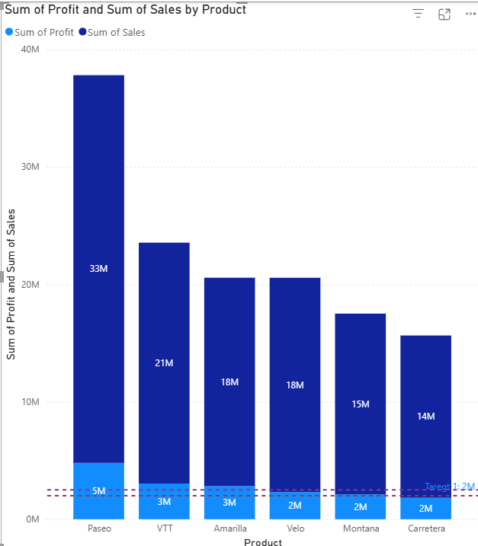

**STEPS:**

* To Display the target in our data we use target lines.
* The target lines can be represented in bar and column charts.
* In case of stacked charts, we can only represent target lines, but incase of clustered charts we can create target lines, minimum line, maximum line, average line.
* Firstly, start creating a stacked column chart with product in x-axis and sales in y-axis and profit in legend.
* Then go to visualization pane, go to add further analysis to the chart.
* Click on add target line add the line name, value at which we need the target line for the target line 1 the value is 2M and change the format of line as dashed/dotted.
* We can change the value format of the value of target line, width of the line, we can represent both name of line and value of the target in the position of line below or above the target line.

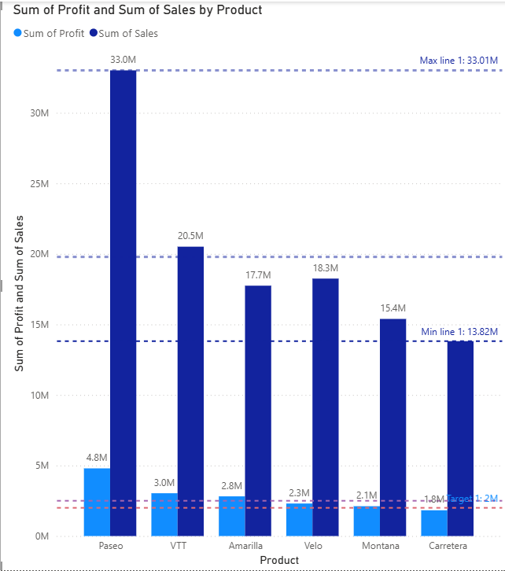

**STEPS:**

* To Display the target in our data we use target lines.
* The target lines can be represented in bar and column charts.
* In case of stacked charts, we can only represent target lines, but in case of clustered charts we can create target lines, minimum line, maximum line, average line.
* Firstly, start creating a stacked column chart with product in x-axis and sales in y-axis and profit in x-axis.
* Then go to visualization pane, go to add further analysis to the chart.
* Click on add target line add the line name, value at which we need the target line.
* We can change the value format of the value of target line, width of the line, we can represent both name of line and value of the target in the position of line below or above the target line.
* Click on add target line add the line name, value at which we need the target line for the target line 2 the value is 2.5M and change the format of line as dashed/dotted.
* We can add the minimum line on the value of profit and minimum line automatically comes and we can format it.
* We can add the maximum line on the value of profit and maximum line automatically comes and we can format it.
* In case of Stacked chart the zero axis is above the sales and so we cannot generate any other lines but in clustered charts the both follow zero axis so we can generate many.

**2.DRILL DOWN AND DRILL THROUGH**

**For each categorical data create pie chart for sales (concept: drill**

**down with drill through)**

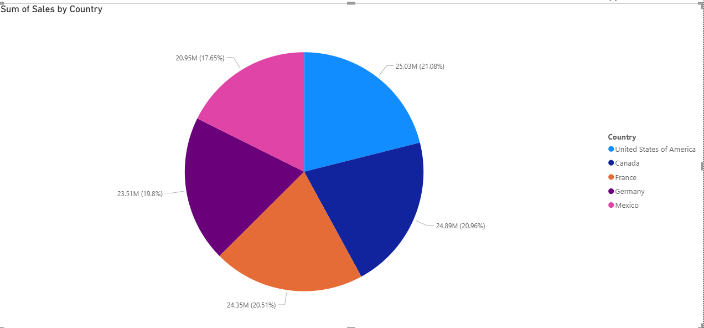

**STEPS:**

* We should start by creating pie chart with product, discount band, segment, country and sum of sales in another axis.
* Then the pie chart gets generated with three arrows on the top right corner.
* Top arrow is drill up and drill down is represented by below arrow and we can merge move to the next chart by two parallel down arrows and we can merge the two charts with the next symbol.

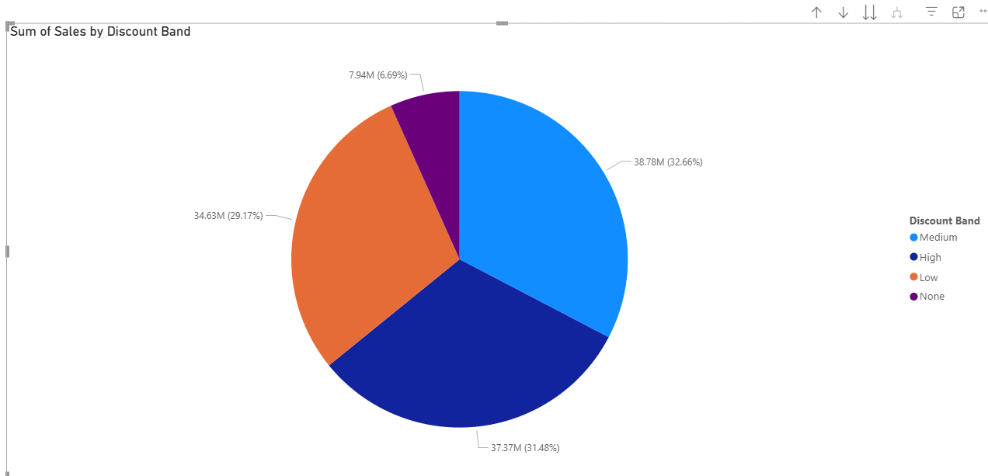

* This concept saves the time and going through the details is easy this way.

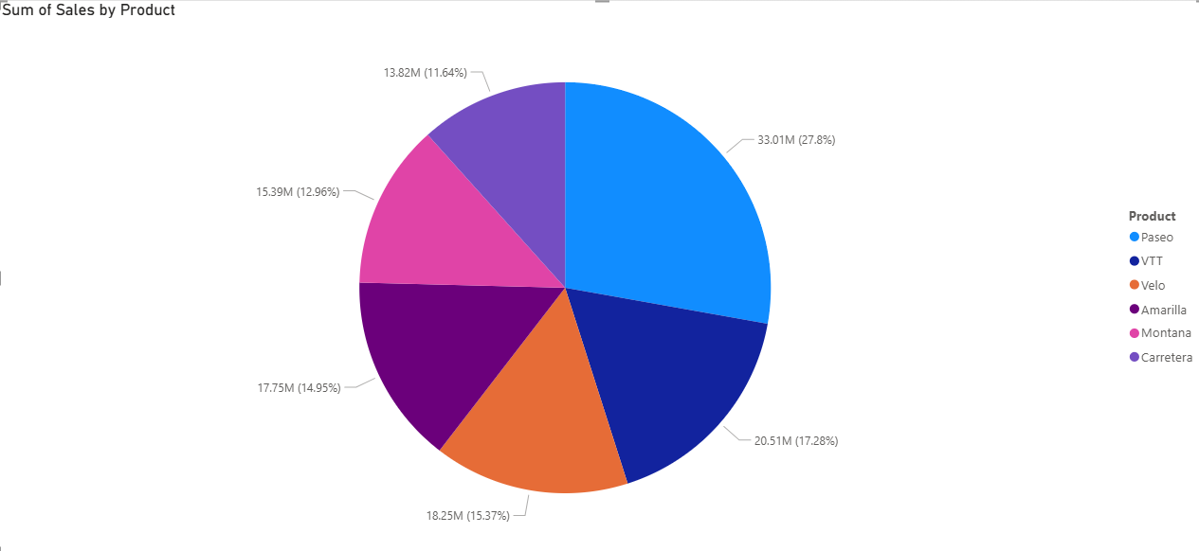

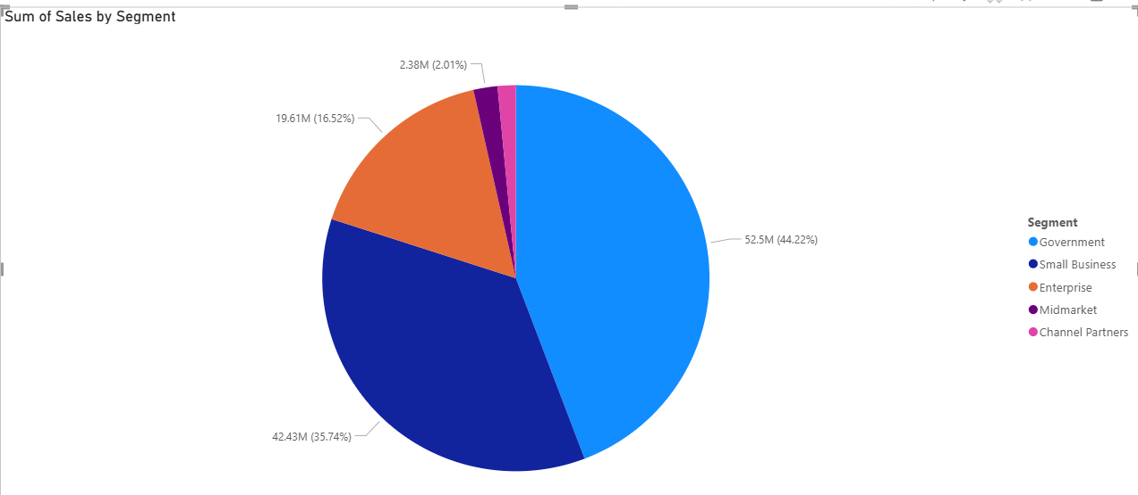

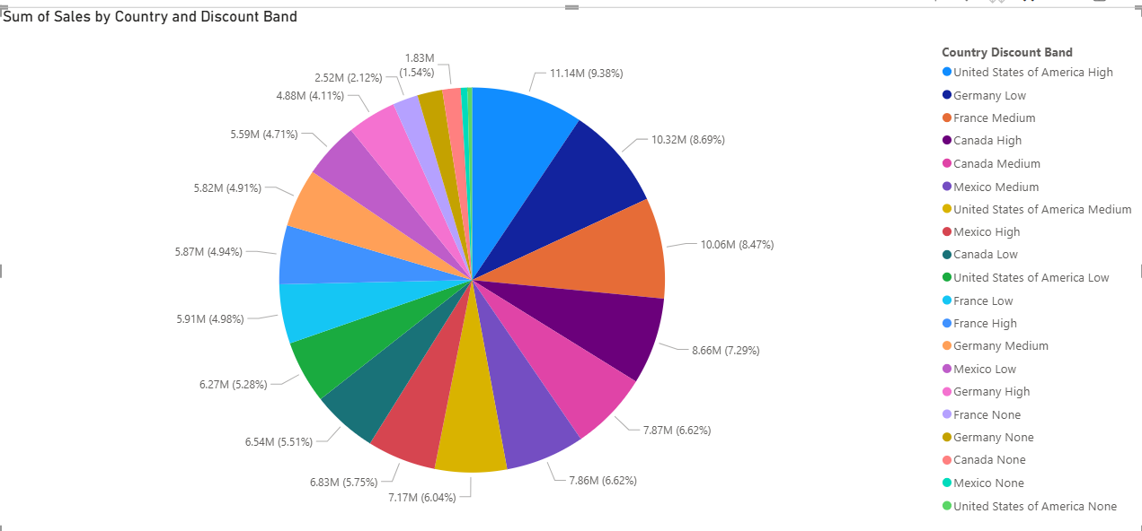

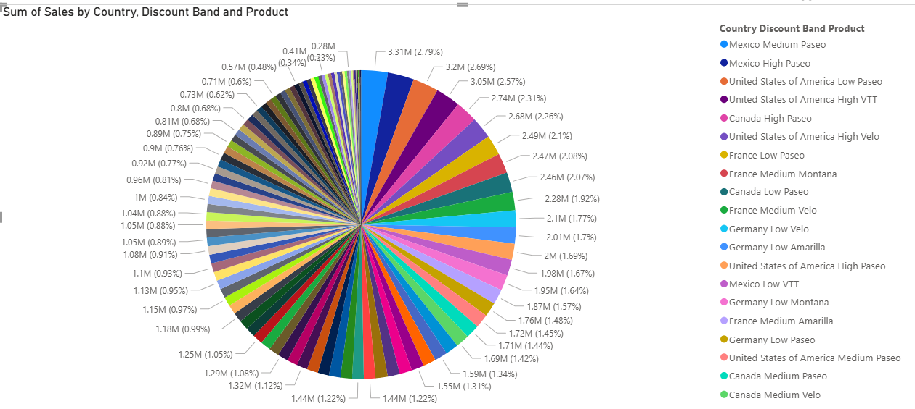

* Turn on the drill down and select any country first and then select the discount band and drill down further to the segment related to it and finally we can look into the details we want in one chart effectively.

**3.SLICERS AND DATE**

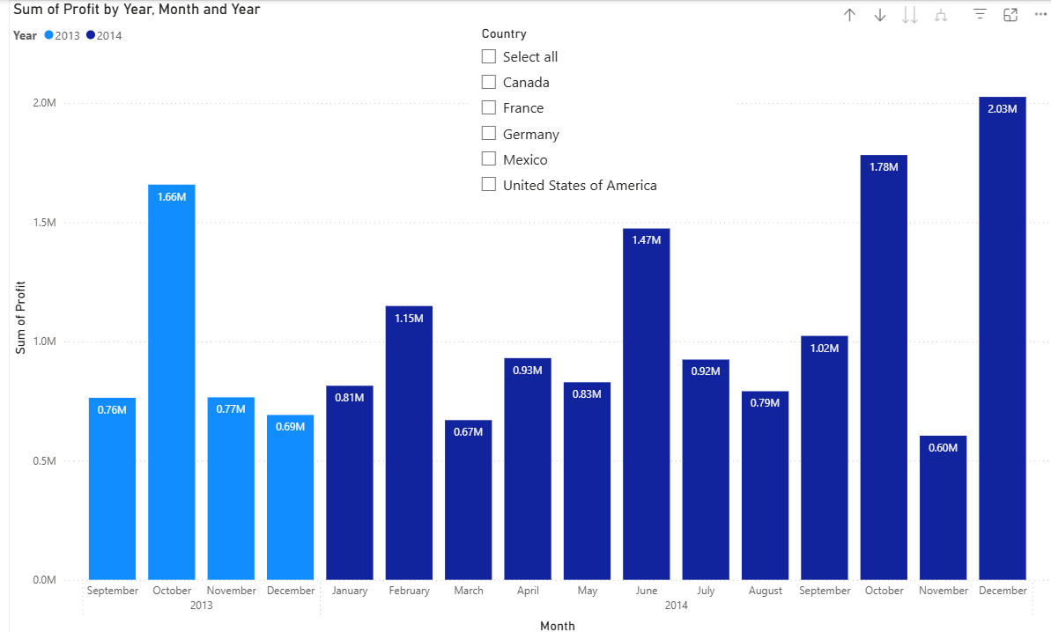

**STEPS:**

* Create a column chart with date in x-axis and profit in y-axis keep only year and month in the date.
* Turn on the data labels initially we can only see only few bars and drill down to see all the bars.
* We can see country wise profits by using a slicer.
* Add the slicer for the country and we can change the settings of the slicers.
* The slicer can be changed to checkboxes when we need to select multiple options.
* The slicer can be changed to radio button to the data which need only one value.
* Enable select all option to make it easier when we had to see all the data.
* We can drill down to see more details in the chart like the above.